**Leaders｜What to do about myopia**

**社论｜近视了该如何应对？**

(英文部分选自经济学人20220611期社论版块)

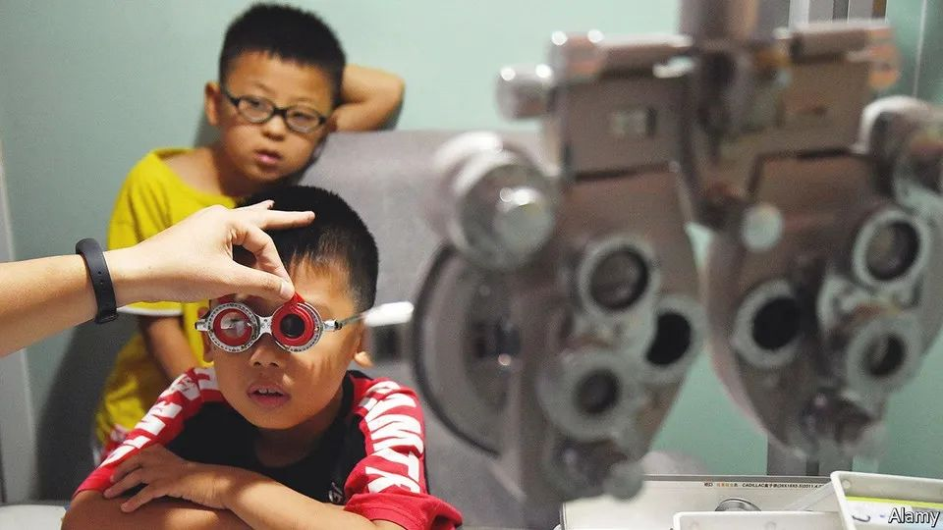

Short-sightedness has become an epidemic

近视已成为一种流行病，如何应对？

To fight it, schools should send their students outside

学校应让学生走出教室，“目”浴阳光

①Few things come with no downsides at all. Rich countries have almost completely **banished** infectious diseases such as tuberculosis, cholera and malaria. Instead, their health ministries spend much of their time worrying about illnesses caused by wealth. Cheap, calorie-dense food has **abolished** starvation in the rich world, but it also encourages diabetes. Sedentary, white-collar jobs are less arduous (and less lethal) than manual work. They also promote obesity and heart disease.

金无足赤，白璧微瑕。富裕国家几乎已经完全消灭了结核、霍乱和疟疾等传染病。但如今，他们的卫生机构却要花费大量时间思考如何应对那些“富贵病”。在富裕国家，价格低廉、富含热量的食物消除了饥饿，但也引发了糖尿病。相比体力劳动，久坐不动的白领工作更加轻松，更鲜有性命之虞，但肥胖和心脏病也随之而来。

②Even education is not always an unalloyed good. Over the past few decades, East Asia has seen a stunning rise in the rate of short-sightedness. And a growing pile of evidence suggests that the main underlying reason for this is education—specifically, the fact that children spend large parts of the day in comparatively dimly lit classrooms.

即使是教育也并非百利而无一害。过去几十年，东亚地区的近视率出现了惊人增长。越来越多的证据表明，造成这一现象的主要原因就是教育——确切地说，是因为孩子们每天大部分时间都在光线相对昏暗的教室中度过。

③Before the long economic booms that began in the 1960s, myopia was uncommon in East Asia. These days, among the young, it is almost ubiquitous. In Hong Kong, Singapore and Taipei more than 80% of school-leavers are short-sighted. In Seoul over nine in ten young men are. China, which began its economic rise later, is catching up. Data from as far afield as Guangzhou in the south and Inner Mongolia in the north show myopia rates among young people of about 80%.

在20世纪60年代开始的长期经济繁荣之前，近视现象在东亚并不多见。但如今，年轻人几乎人人近视。在香港，新加坡和台北，超过80%以上的中学毕业生近视。在首尔，每十个年轻人中有九个近视。在经济崛起较晚的中国，近视率也直逼上述城市。数据表明，无论是远在南方的广州，还是北边的内蒙古，年轻人的近视率均达到约80%。

④If East Asia is the centre of the epidemic, the West is not immune. Good data are harder to come by. But studies suggest rates of between 20% and 40% in Europe, an order of magnitude higher than the natural state of affairs. One study in California found a rate of 59% among 17- to 19-year-olds.

如果说东亚是近视这场流行病的中心，西方也未能幸免。尽管缺乏精准可靠的数据，但据研究估计，欧洲的近视率在20%至40%之间，这比自然状态下高出一个数量级。加州的一项研究也发现：17至19岁人群的近视比例高达59%。

⑤There are, admittedly, worse things to suffer from. But short-sightedness is not always benign. Glasses and contact lenses are an expensive, lifelong hassle. In parts of rural China, where some families cannot afford either, children struggle in the very schools that are causing the problem. And severe myopia predisposes those enduring it to other eye diseases in middle age, some of which can cause untreatable loss of vision. Governments in Asia are increasingly worried about the public-health implications of entire generations growing up short-sighted. Those in other parts of the world should start worrying, too.

Be well, ideally, uniquely, better, etc. placed for sth/to do sth

有良好的（或理想的、独特的等）机遇；处于有利等的位置

Make, etc. a dent in sth

减少，削减（尤指资金）

当然，有许多比近视更令人糟心的大事（需要我们面对），但这并不意味着近视是一件无足轻重的小事。眼镜和隐形眼镜价格昂贵，且一般终身无法摆脱。在中国部分农村地区，一些家庭无力支付眼镜费用，而这些家庭的孩子，不得不在给他们造成视力问题的学校里，继续艰难求学。严重的近视会使人在中年时更易患上其他眼疾，其中一些还会导致无法治愈的失明。亚洲各国政府越来越担心，一整代人的成长过程都伴随着近视，这会给公共健康带来影响。世界其他地区也应该开始防微杜渐了。

⑥The evidence suggests that regular exposure to bright daylight is vital in properly controlling the growth of children’s eyes. Too little light leads to elongated, short-sighted eyes. Researchers think that this explains why rates are so high in Asia, where a strong cultural emphasis on the value of education leads to long school days and, often, private tutoring in the afternoon and evening. That leaves little time for sunshine. Western children, whose parents are increasingly worried by a hyper-competitive jobs market that threatens much less secure employment than they enjoyed, are beginning to go the same way.

有证据表明，经常暴露在明亮的日光下，对于儿童眼睛的生长发育至关重要。接触阳光太少，会导致眼轴变长，从而造成近视。研究人员认为，亚洲近视率高的原因正在于此，因为亚洲文化注重教育，儿童上学时间长，下午和晚上往往还需要补习。这导致他们几乎没有时间晒太阳。而在西方，现在就业市场竞争日益白热化，父母们日益担忧他们的子女可能无法像他们那一代获得稳定的就业，因此也开始走亚洲父母的老路。

⑦Special eyedrops, as well as clever glasses and contact lenses, may be able to slow the progression of myopia once it has started. But prevention is better than mitigation, and the science suggests a cheap, straightforward measure. A series of encouraging trials, many conducted in Taiwan, show that giving schoolchildren—and especially those in primary education—more time outside can cut the number who go on to develop myopia. An island-wide policy of doing just that seems to have begun reversing the decades-long rise in myopia rates. Similar attempts in Singapore relied on parents, who proved more reluctant to change their behaviors, perhaps worried that other parents might not follow suit, leaving their children at a disadvantage in the classroom.

一旦眼睛近视，特制眼药水、精巧的眼镜和隐形眼镜也许能够延缓近视加深。但事前预防总胜于事后补救，而科学表明其实有一种直截了当又成本低廉的方法。一系列令人振奋的试验（其中很多在台湾开展）表明，给予学童，尤其是小学生，更多的户外活动时间，能有效降低日后近视发生率。一项在台湾全岛实施的政策正是采取了相应措施，当地几十年来持续上升的近视率似乎已开始得到扭转。在新加坡，类似措施的实施依赖父母，而事实证明，相较于台湾父母，他们改变自己教养方式的意愿更弱，也许是因为担心其他家长做法如旧，自家孩子在学业上落于人后。

⑧Governments are well placed to solve such collective-action problems, while reassuring anxious parents that a bit less classroom time is unlikely to be catastrophic. After all, countries such as Finland and Sweden do well in global education rankings with a less intense approach to education. Giving more outdoor time to young children would still leave room for them to cram for exams in their teenage years. And longer breaks in the playground may also make a dent in other rich-world problems such as childhood obesity. Far-sighted governments should send the kids outdoors.

政府可以很好解决这类需要集体行动的问题，同时让焦虑的家长们放心，课堂学习时间少一点，不会造成严重后果。毕竟，像芬兰、瑞典这样在全球教育排名中位居前列的国家，他们的学习强度并没有那么大。给孩子们更多户外活动时间，并不妨碍他们在青少年时期为考试拼命学习。更多的课间操场活动时间，还有助于改善富裕国家的一些其他问题，例如儿童肥胖。富有远见的各国政府是时候让孩子走到户外了。

【自我总结】

P1. More and more rich countries spend more attention on illness caused by wealth, short-sightedness.

P2. A main reason of this phenomena is education.

P3. Before the long economic booms that began in the 1960s, myopia was uncommon in East Asia, but it is almost ubiquitous now.

P4. These phenomena occur both in Asia and West.

P5. The influence of it.

P6. According to the evidence, being exposure regularly to bright daylight is vital in properly controlling the growth of children’s eyes.

P7. Prevention is the science and straightforward measure.

P8. Government is responsible for it.